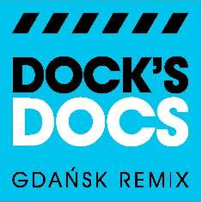
Remix the docks!
We invite you to participate in Dock's Docs Gdańsk Remix competition for the best collage of video documentaries from the Gdańsk Shipyard and Solidarność (Solidarity). We provide the video material, you mix it, record the musical score, process and play with it. Dock's Docs competition is your space of freedom. Until April 30 create a short and win a scholarship in Parisian school Ina Sup and a VIP invitation to the European Culture Congress in Wrocław (8-11 September 2011)!

In the frame of the impending Polish EU Presidency 2011, the Polish National Audiovisual Institute (NInA) and l’Institut National de l’Audiovisuel (Ina) open the archive that contains recordings of the key events of the contemporary history of Europe. Participants will be able to use them in order to tell their own original story. The entries can be based fully or partly on the provided archive records. We encourage all forms of artistic creativity and intervention– animation, music, samples, fragments of your own films.

To take part in the competition visit www.dailymotion.com/gdanskremix
More information: www.culturecongress.eu
Contact: gdanskremix@nina.gov.pl

